**Screenshots from steps 3 and 5**

{geometry: {

$geoWithin: { $polygon: [ [ -116.15907084356105 , 33.98096522850808 ], [-107.89027837388127, 34.91493770120391], [ -112.49490593840095 , 41.63074261463882 ] ] }

}}

**Step 3:** Google Earth downloaded on laptop and .kml file comprising of the 13 locations captured below. (Please find the locations with blue points in the map below)

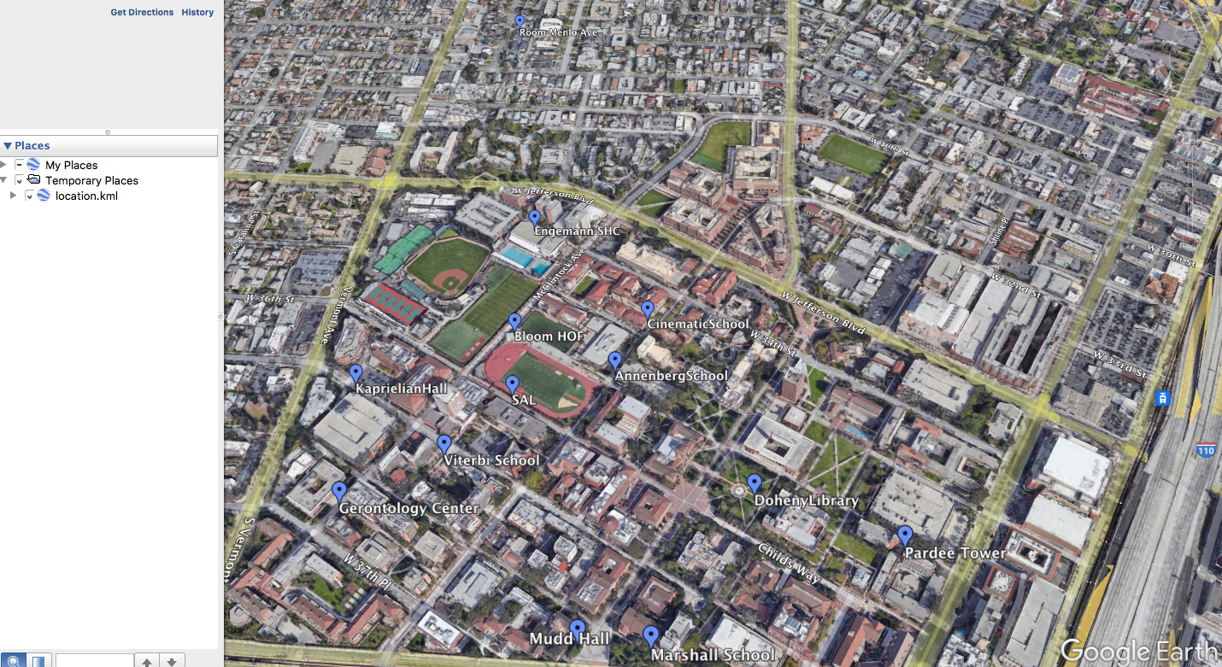

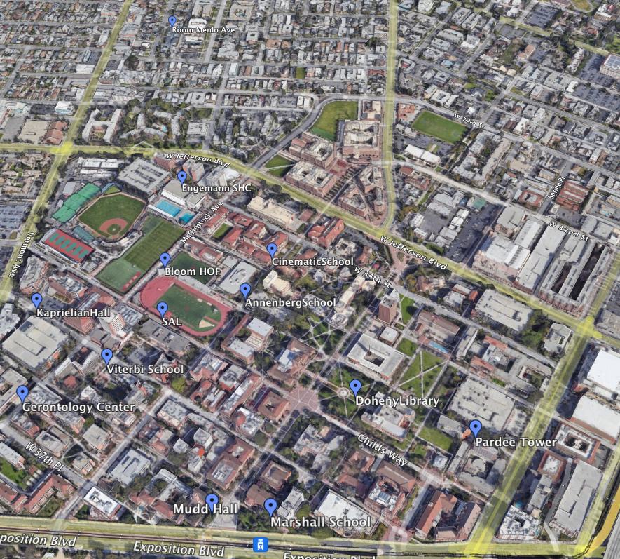

**Step 5:**

1. **Convex Hull (only)**

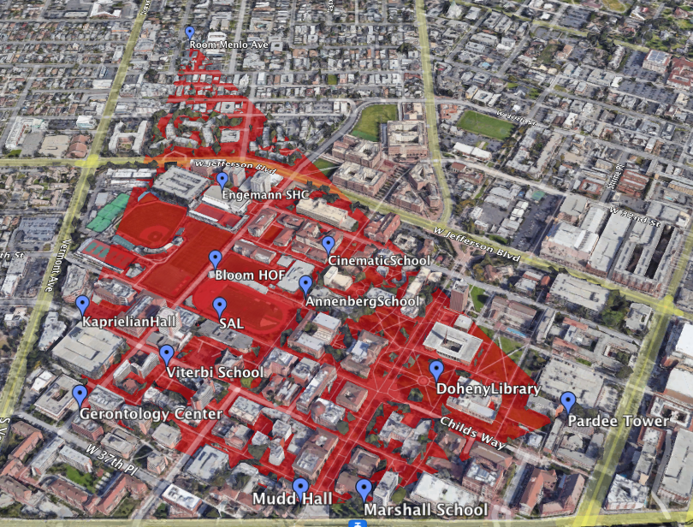

1. **K-Nearest Neighbors**

